**BRM LAB-6**

**Aim**: **Create a simple Maven Project using CLI.**

Solution: Steps required are as follows-

* Creating a Project-

First switch to the workspace where the project has to be created.

Then run the following command.

**mvn archetype:generate -DgroupId=com.mycompany.app -DartifactId=my-app -Darchetyp eArtifactId=maven-archetype-quickstart -DarchetypeVersion=1.4 -DinteractiveMode=false**

The above command needs to be run to create a project. It is defining group id, artefact id and version. This represents the unique identity of the project.

Here’s the output of the above command-

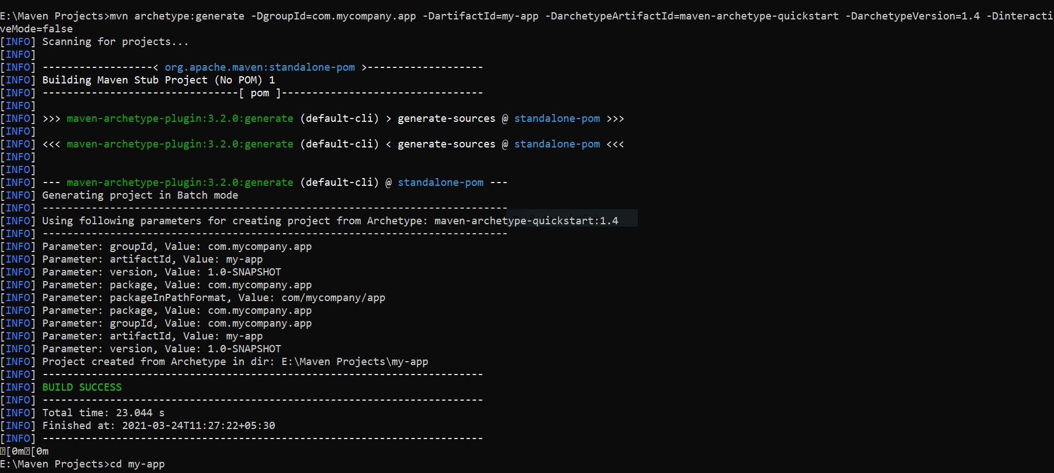

Build is successful that means required project has been created.

This is pom.xml file which is created inside the target folder. It is a single configuration file that contains the majority of information required to build a project.

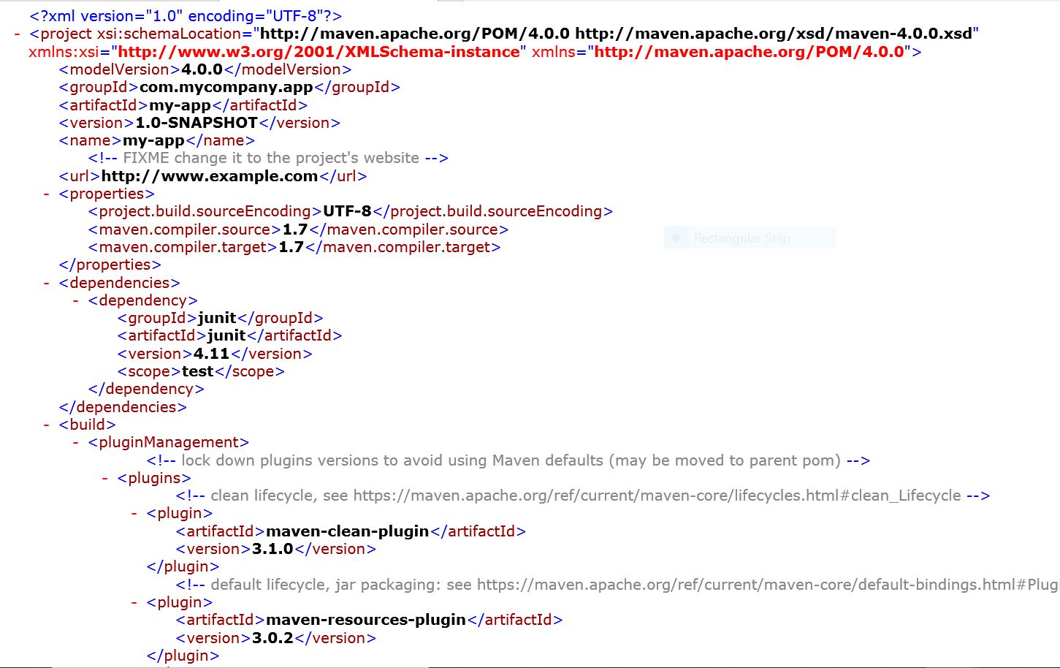

Now, the generate goal created a directory with the same name given as the artifactId. Change into that directory by using following command.

**cd my-app**

* Build the Project-

Run the following command-

**mvn package**

This will create a jar file inside the target folder. Following is the output-

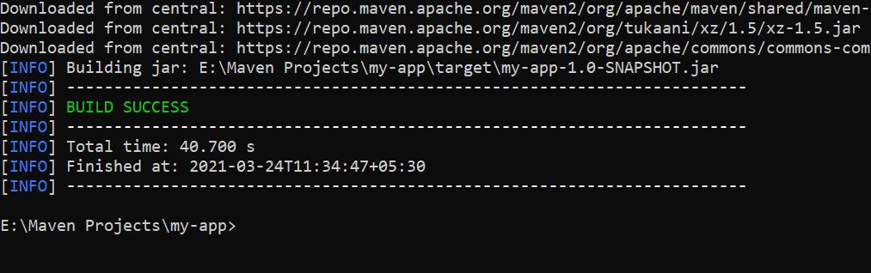

Now, test the newly compiled and packaged JAR with the following command:

**java -cp target/my-app-1.0-SNAPSHOT.jar com.mycompany.app.App**

Basically with this command we are accessing the class file which is present inside the jar file and it will print the quintessential.

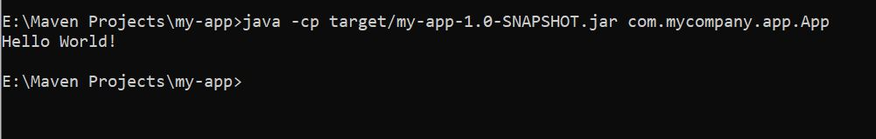

Since the artifact id we mentioned was **maven-archetype-quickstart**, which has by default print hello world program of java present and so it get executed and we get the following output.